**Task 1**

* 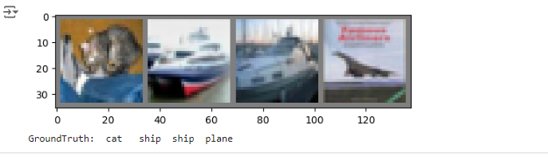Test the network on the data set:
* How the network preforms on the whole dataset:
* what are the classes that performed well, and the classes that did not perform well:

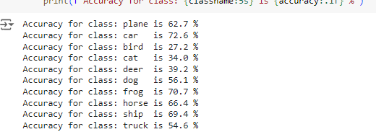

**Task 2**

* Report the classification error (in accuracy) of the test set

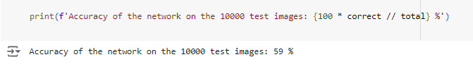

* show two-three examples of reconstructed images alongside the original images.

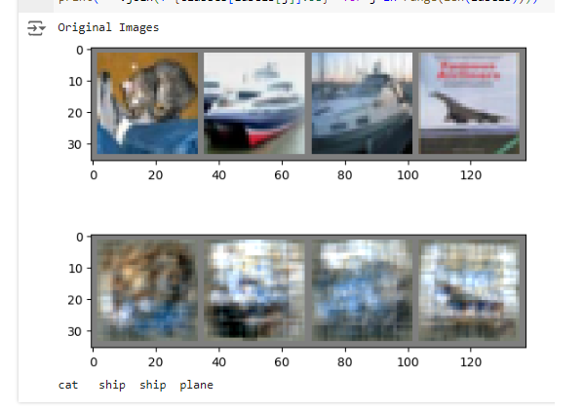

**Task 3**

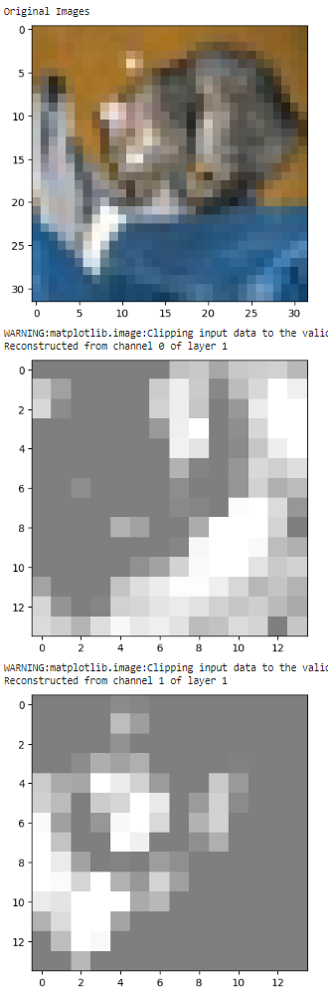

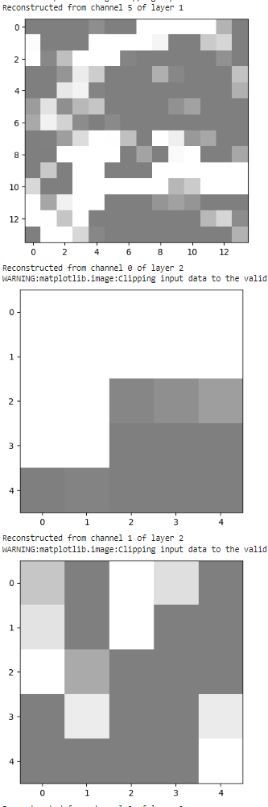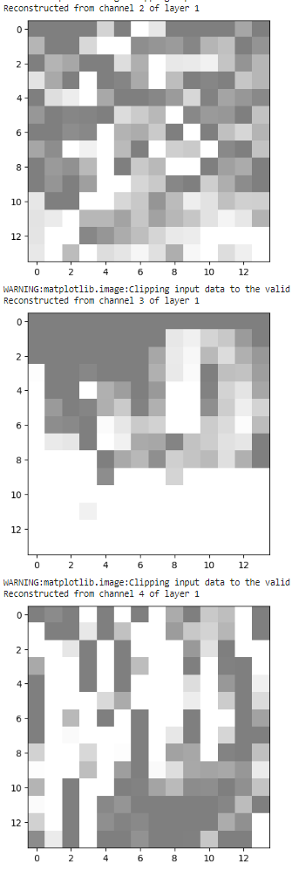

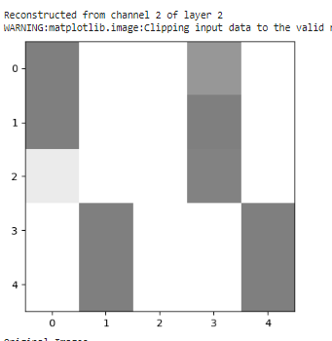

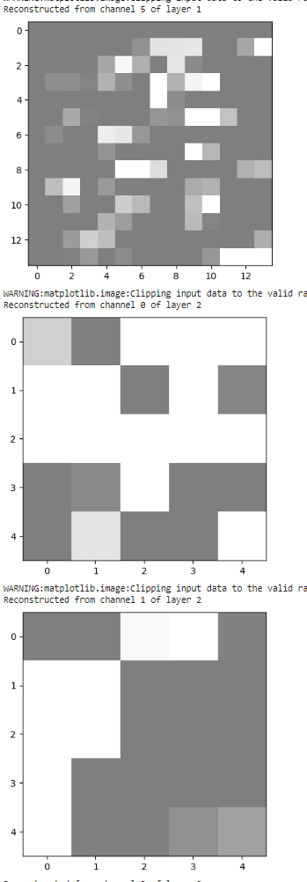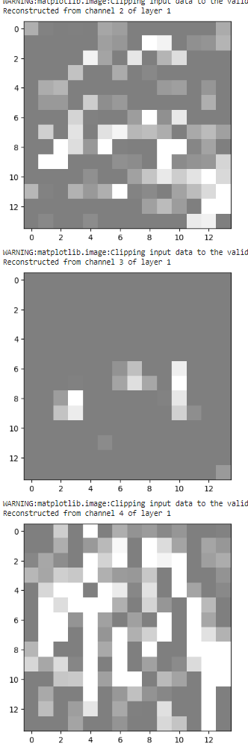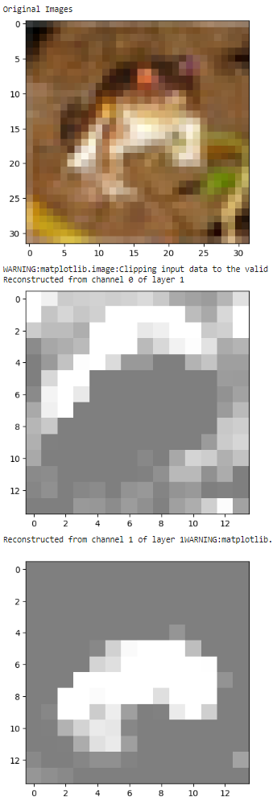

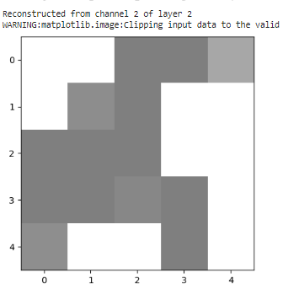

In the first layer, the network detects shapes and contours of objects in the image. In the second image, you can see that the first channel of the first layer clearly shows the contours of the frog. However, in the second layer, it is not currently possible to draw any definitive conclusions, likely because the pixels are too large in relation to the image.